Grade 7 Accelerated · Unit 3 · Lesson 2  Quotient Laws of Exponents  Question Bank - Additional 3.02 | Name______________________  Date______________________  Period____________________

Show your work. Circle your final answer.
For questions 1 through 3, show the quotient of powers law, then evaluate.
1. 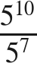

2. 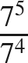

3. 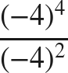

4. When raising a fraction to a power, the numerator and the denominator are each raised to the ______ power.

For questions 5 and 6, apply the power of a quotient law. Do not simplify the fraction.
5. 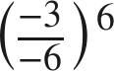

6. 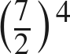

The zero exponent.
7. Fill in the missing value in the pattern: 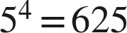, 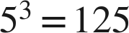, 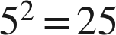, 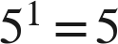, 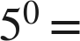 ____

8. Evaluate  and 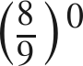.

For questions 9 and 10, rewrite the expression using a law of exponents, name the law, then evaluate.
9. 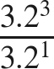

10. 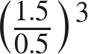

Working backwards.
11. Find the value of that makes each statement true.
a. 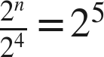

b. 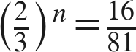

c. 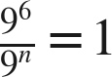

12. Which expression is equivalent to 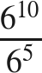 ?
○ A. 
○ B. 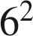
○ C. 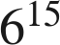
○ D. 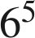

13. Select ALL of the expressions whose value is 1.
□ A. 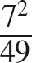
□ B. 
□ C. 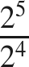
□ D. 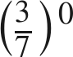
□ E. 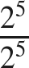
□ F. 

